COSC 4377 – Intro to Computer Networking - Kevin B Long

Study Guide for Midterm Exam

Fall 2018

Most of this will be on the exam, but some will be dropped for time. Bring a double-sided cheat sheet, this guide with any notes on it, a calculator and a writing instrument. No blue books, no scantrons.

**Important!** Reference diagrams and tables and equations that are included in this study guide will probably not be duplicated again in the exam, so if you need them, you must print and bring this guide to the exam or bring it on an iPad as a PDF, etc.

1. Remember the five layers of the TCP/IP protocol stack and which layers each device covers: routers to layer 3, switches to layer 2, when they are routing and switching. Assume programs run at the application layer unless you know otherwise. When you connect to a device to exchange data from an application on some host to the companion application on that device, you’re connecting at the application layer, regardless of the device’s usual job.

**Application**

* **Protocols such as HTTP,SMTP, and FTP**
* **Use transport layer protocols for establishing host –host connection**

**Transport**

* **Responsible for client and server of application**
* **Uses two protocols for transporting messages such as TCP and UDP.**

**Network**

* **Sends packets from one host to destination.**
* **Routing protocols between source and destination**

**Data Link**

* **Responsible for link-level communication**
* **Sends entire frames from one network element to the next one**

**Physical**

* **Moves individual bits of frames to the next**
* **Provides physical media**

Review question 5 on HW 1.

1. You will have another question like #6 on HW 1.

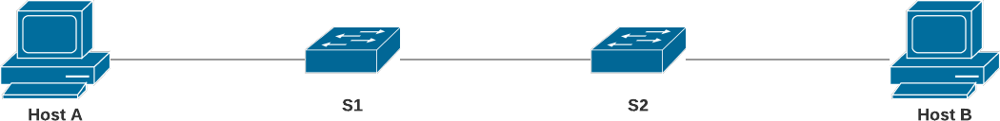

Know how to calculate end-to-end delay as we did in the problem. Bring the equations with you.

**a. Can you generalize the equation to 2 hosts, N links (and so N-1 network devices), and P packets?**

**Answer:**

**Total end-to-end delay = P*((N-1) * (L/R))**

**b. If we add propagation delay dprop to each link, can you generalize the equation further?**

**Answer:**

**Total end-to-end delay = P*((N-1) * (L/R + dprop))**

$$d_{end-to-end}=N\frac{L}{R}$$

1. Remember the four types of delay – propagation, transmission, queueing, and processing and where they occur. Be able to spot them on a diagram.

Processing and Queueing delays happen inside of routers.

Transmission delays happen inside of every device as it is sending a packet. Propagation delays happen outside of devices – between them, actually, on the networks.

Reviewing #8 on HW 1 will also give you the equations you need to calculate a

COSC 2440 – Computer Organization and Architecture

specific delay if asked.

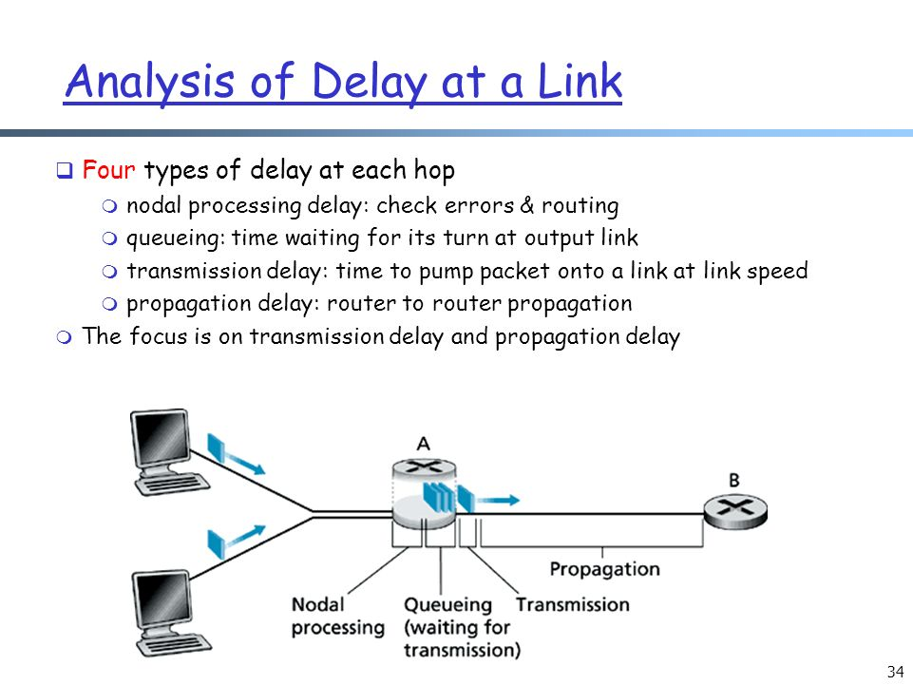

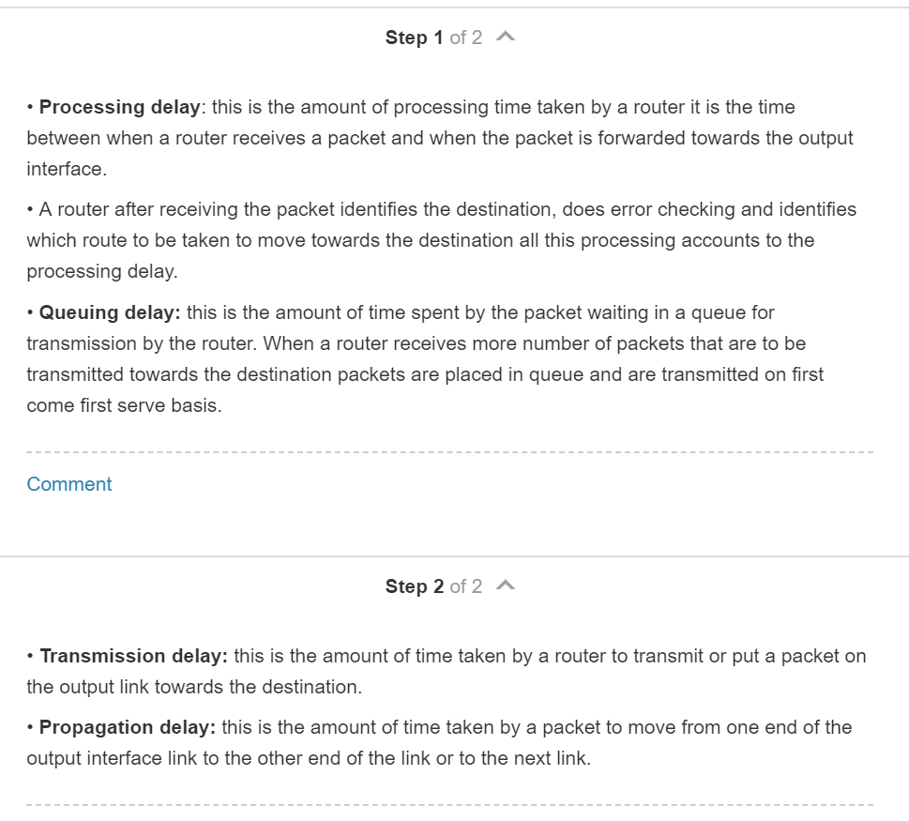

1. Express the propagation delay, *dprop*, in terms of *m*and *s*.

**Answer:**

**M = meters between hosts**

**S = propagation speed**

**m/s = dprop**

1. Determine the transmission time of the packet, *dtrans*, in terms of *L* and *R*.

**Answer:**

**L = number of bits to transmit**

**R = rate of transmission**

**Dtrans = L/R**

1. Ignoring processing and queuing delays, obtain an expression for the end-to-end delay.

**Answer:**

**L/R + m/s**

1. Suppose Host **A** begins to transmit the packet at time *t* = 0. At time *t* = *dtrans*, where is the last bit of the packet?

**Answer:**

**The last bit of the packet is on the link (I guess you could say on the wire), ready to propagate to Host B.**

1. Suppose *dprop* is greater than *dtrans*. At time *t* = *dtrans*, where is the first bit of the packet?

**Answer:**

**If the propagation time is greater than the transmission time, then the first bit of the packet would be propagating across the link to Host B at this time. Its actual distance from Host B would decrease as t approaches dprop.**

1. Suppose *dprop* is less than *dtrans*. At time *t* = *dtrans*, where is the first bit of the packet?

**Answer: The first bit of the packet would have arrived at Host B at this time.**

1. After how much time will the first bit be delivered to the waiting application on Host B?

**Answer: Shortly before the end-to-end delay time, since it will be the first bit to arrive at the Host B machine after having propagated across the link.**

1. Suppose *s* = 2.5 x 108*m/s*, *L* = 200 bits, and *R* = 56 kbps. Find the distance *m* so that *dprop* equals *dtrans*. Round to the nearest kilometer.

**Answer:**

**S = propagation speed = 2.5 x 10^8 m/s = 250000kmps**

**L = total number of bits = 200 bits**

**R = transmission rate = 56kbps = 56000 bits**

**M = distance between hosts**

**Dprop = m/s = (m/250000)**

**Dtrans = L/R = 200/56000**

* + - **Dprop = dtrans 🡪 (m/250000) = (200/56000)**

**M = 893KM**

1. We saw lots of time diagrams in the book and in our lectures. On them, time goes down the page. No exceptions. So when you are drawing a diagram, and need to indicate or recognize delay, think about how a very large delay versus a small delay of each type will appear in a time diagram. How can you spot large vs small? Here’s an example of a timing diagram, a very simple one. The only type of delay that’s significant on this diagram is propagation delay.

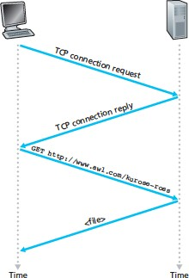

1. We may have a caravan question like #7 in HW 1. It would be just a simple variation, so if you review the problem you’ll be set.
2. Assume a propagation speed of 100 km/hour.
3. Suppose the caravan travels 150 km, beginning in front of one tollbooth, passing through a second tollbooth, and finishing just after a third tollbooth. What is the end-to-end delay? Hint: assume tollbooths are 75km apart. Then calculate how many seconds a tollbooth needs to service one car. Then you can work out how many seconds to service all cars, and how long each car’s propagation delay is for the 75km before arriving at the second tollbooth. How long before they’re all in front of the second tollbooth? You repeat the whole process again from the second to the third tollbooth, where there is a servicing delay once again. That’s your total.

**Propagation speed = 100 km/hr**

**Time to take to reach a single car = 12 seconds**

**Total distance/Propagation speed = (150km)/(100km/hr) = 1.5 hrs 🡪 Propagation delay**

**To reach up to 10 cars: 10 * 12 = 120 seconds = 2mins 🡪 Transmission delay**

**End to end delay = N(PD + TD)**

**End of end delay = 1 hr and 36 mins**

**Transmission delay = (150km/)(100km/hr)**

1. Repeat (a), now assuming that there are 12 cars in the caravan instead of ten.

**Num of cars = 12**

**Total distance = 150**

**Total distance/Propagation speed = (150km)/(100km/hr) = 1.5 hrs 🡪 Propagation delay**

**12 cars = 12 x 12 = 144 seconds**

**144 * 3 tollbooths = 432 seconds 🡪 7.2 mins**

**7 mins and 12 secs + 1hr and 30 mins = 1 hr 37 min 12 secs 🡪 End to End delay**

1. Review question 12 on HW 1 – I am likely to have a queueing question, perhaps with packets of different sizes. The equation we used for queueing delay on that problem was:

(5 pts) A packet arrives at a router which makes a decision about the next link over which it is to travel. There is a buffer for that link which currently holds 4 packets. There is one packet that is 50% transmitted. Assume packets are all 1,500 bytes, and the link has a bandwidth of 2 Mbps.

1. How long will this packet have to wait before its transmission can begin? This is the queueing delay.

**The number of packets in the buffer above is: 4  
   Each packet has 1500 bytes**

**Additionally, one packet is 50% transmitted   
   Link speed = 2 Mbps**

**Wait time = Complete transmission of current packet + 3 more packets  
             = (750 * 8)/(2*10^6) + 3 * (1500 * 8)/(2*10^6)  
             =   42000/(2*10^6)  
             =   21 * 10^-3  
             =   21 ms**

**Thus, 21 ms will be the time this packet have to wait before its transmission can begin.**

1. Can you generalize the equation for queueing delay for a particular queue if arriving packets have length *L bits*, the transmission rate is *R*, *x* bits of the currently-being-transmitted packet have been transmitted, and *n* packets are already in the buffer (queue)?

**Wait/Buffer Time = (L-x)/R + n * (L/R)**

𝐿𝑛 + (𝐿 − 𝑥) 𝑏𝑖𝑡𝑠

𝑅 𝑏𝑖𝑡𝑠/𝑠𝑒𝑐

1. Recognize the four types of choices from the book’s HTTP Delay estimator here: https://media.pearsoncmg.com/aw/ecs_kurose_compnetwork_7/cw/content/interactiveanim ations/http-delay-estimation/index.html

Remember, parallel and pipelining in this simulator are considered the be the same thing, and they will be on the exam as well.

a. Which connection type always requires the greatest total time to retrieve the page and its objects?

Non-Persistent Connection

b. Which type requires the least amount of total time?

Persistent Connections with Pipelining

For the following four questions, there are 4 objects being transmitted, and when we have the chance we will choose 4 parallel connections.

1. Which type of connection does this represent (assume 4 objects)? Persistent Connections with Pipelining

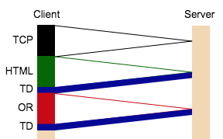

1. Which type of connection does this represent (assume 4 objects)? a non-persistent connection with parallel connections

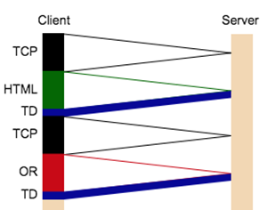

e. Which type of connection does this represent (assume 4 objects)?

Non-Persistent Connection

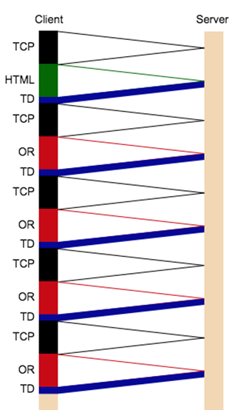

f. Which type of connection does this represent (assume 4 objects)?

Persistent Connections without Pipelining

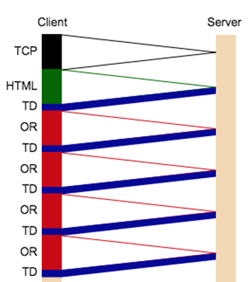

1. You’ll likely see a Wireshark dump like problem 3 in HW 2. Be able to answer similar questions in a different trace file.

(8x2 pts) Use Wireshark to capture a trace to <http://www.uh.edu>. Filter for HTTP, and export it using Wireshark’s File menu. I had the best results choosing Export Packet Dissections as Plain Text.

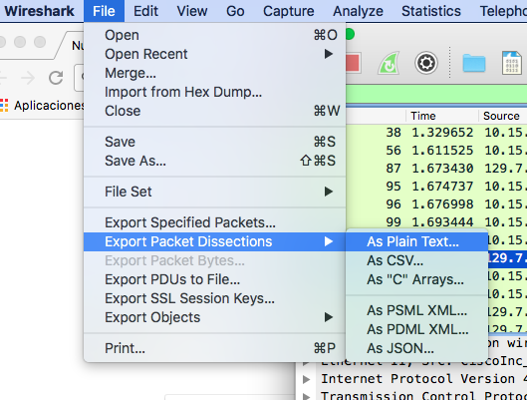

Throw all the packet traces away except the very first GET and its response. If you click on the first GET, Wireshark will give you the number of its corresponding response. Then you know what to toss from your export. Paste the resulting pair of packets below as plain text, and then answer the following questions, highlighting in your packets where you found the answers. If you use Word, you can just use its built-in highlighting tool.

-----Paste your two packets here. -------

**No. Time Source Destination Protocol Length Info**

**27 5.048289 192.168.1.101 129.7.97.54 HTTP 627 GET / HTTP/1.1**

**Frame 27: 627 bytes on wire (5016 bits), 627 bytes captured (5016 bits) on interface 0**

**Ethernet II, Src: Giga-Byt_df:4a:22 (90:2b:34:df:4a:22), Dst: Cisco-Li_e9:72:c5 (00:16:b6:e9:72:c5)**

**Internet Protocol Version 4, Src: 192.168.1.101, Dst: 129.7.97.54**

**Transmission Control Protocol, Src Port: 60585, Dst Port: 80, Seq: 1, Ack: 1, Len: 573**

**Hypertext Transfer Protocol**

**No. Time Source Destination Protocol Length Info**

**90 5.710796 192.168.1.101 129.7.97.54 HTTP 695 GET /cdn/anchorme/js/anchorme.min.js?_=1519011685344 HTTP/1.1**

**Frame 90: 695 bytes on wire (5560 bits), 695 bytes captured (5560 bits) on interface 0**

**Ethernet II, Src: Giga-Byt_df:4a:22 (90:2b:34:df:4a:22), Dst: Cisco-Li_e9:72:c5 (00:16:b6:e9:72:c5)**

**Internet Protocol Version 4, Src: 192.168.1.101, Dst: 129.7.97.54**

**Transmission Control Protocol, Src Port: 60585, Dst Port: 80, Seq: 574, Ack: 18233, Len: 641**

**Hypertext Transfer Protocol**

1. I’ll try to ask some meaningful questions about what we learned from the long exercise on HW 3.